Why do some parameter values lead to more convergent events?

1. The simulation results show that convergent trends are observed only when there is a threshold to competition and high levels of intraspecific trait variation.
2. In our framework, when only two species are competing, their traits will always diverge from each other until they no longer compete. Therefore, convergent trait evolution between a given pair of species is essentially a result of a balance between the competition between that pair of species and the effect of diffuse competition.

This issue can be further explored with the use of the β function that determines the per capita effect of competition between a pair of species on the change in their mean trait values. It is a function of distance between the mean traits of competing species.

Functional form of β can derived by solving the following integral:

$$βij=\iint{\left(z-µ_{i}\right)p_{i}(z)p_{j}(z^{'})}α\left(z,z^{'}\right)dzdz'$$

Where, z is the trait of an individual of species i and z’ is the trait of an individual of species j. $µ_{i}$ is the mean trait value of species i. pi(z) and pj(z’) are the probability distributions of traits of species i and j respectively where µ and σ2 are means and variances respectively. α is the coefficient of competition or the competitive kernel. It has a form of Gaussian which is a function of (z-z’).

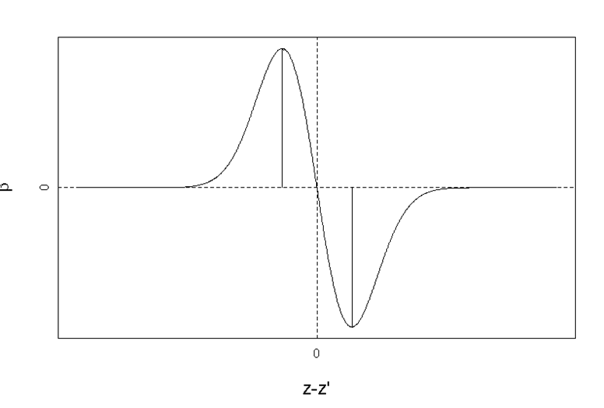

$$\hat{Δ}=\sqrt{{{2σ}_{i}}^{2}+{{2σ}_{j}}^{2}+ω^{2}}$$

$$-\hat{Δ}$$

$$\hat{Δ}$$

$$-\hat{Δ}=\sqrt{{{2σ}_{i}}^{2}+{{2σ}_{j}}^{2}+ω^{2}}$$

Shape of the β function implies that, two species with very similar mean trait values do not have highest impact on each other’s trait evolution. Rather, species with $\hat{Δ}$ as a distance between their mean trait values have the highest impact on each other’s trait evolution.

To investigate whether or not two species will have convergent evolution, let us assume a simplified scenario where all the competing species are identical in terms of their demographic properties (N, K and r values are identical) and have identical intraspecific trait variance and they only differ in terms of their mean trait values or their position along the single trait axis (since the competition is modelled based on a single trait).

Let us choose species A and B as two species which are adjacent along the trait axis. Given that β function depends now on only the distance between the trait values, we can imagine three different scenarios: (In three figures below, all the ticks along the horizontal trait axis represent positions of all the species.)

1. Distance between mean traits of species A and B is very small compared to $\hat{Δ}$, i.e.

| µA- µB |<<

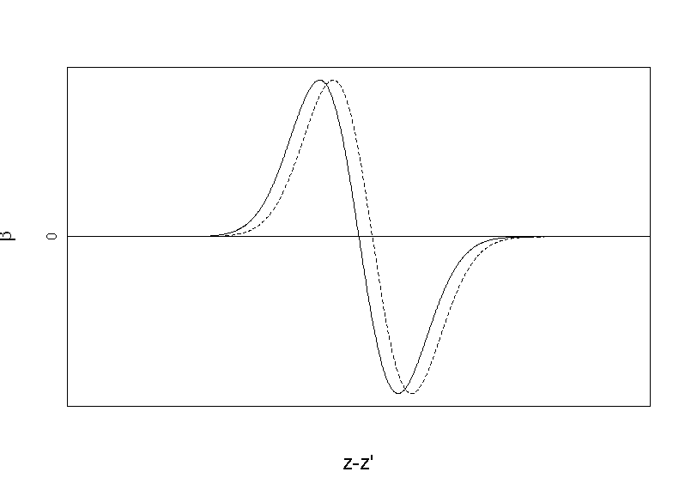

µA

µB

In this case, species A and B have very little impact on each other’s trait evolution. Thus, diffuse competition strongly influences the directionality of their trait evolution. In the figure above, two species adjacent on the left side of species A will have a strong impact since they are close to the optimum trait differences for both A and B and will drive the mean traits of A and B towards increasing values. Similarly, two species adjacent on the right of species B will be major players and will drive the mean traits of A and B towards decreasing values. Thus, the directions of trait evolution of species A and B depends on balance between the effects four neighboring species. Asymmetry between effects of species from the ‘right side’ and ‘left side’ will likely lead species A and B converge towards each other.

In case of threshold to the competition, species located farther than the threshold from either species A or B will have almost no impact on the evolution of A or B.

1. Distance between mean traits of species A and B is very similar to $\hat{Δ}$, i.e.

| µA- µB | ~

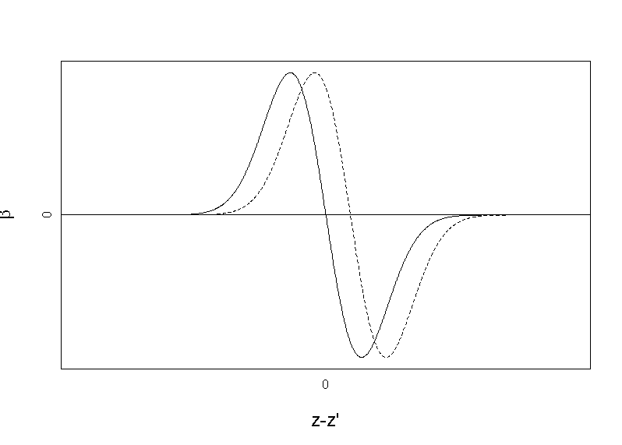

µA

µB

In the example above, species A and B very strongly affect each other’s trait evolution. Consequently, there is less space along the trait axis where other species can influence the evolution of A and B and also, species located on the right side of B will weakly affect species A’s trait evolution and species on the left of A will weakly affect the evolution of B. If there are multiple species located on the left side species A which can strongly affect species A’s trait evolution (position close to the peak of β) , species A’s mean trait will increase (towards left) and similarly if there are multiple species located on the right side of species B that strongly affect B’s evolution, species B’s mean trait will decrease (towards left). This leads to convergent evolution between A and B.

1. Distance between mean traits of species A and B is significantly larger than $\hat{Δ}$, i.e.

| µi- µj | >>

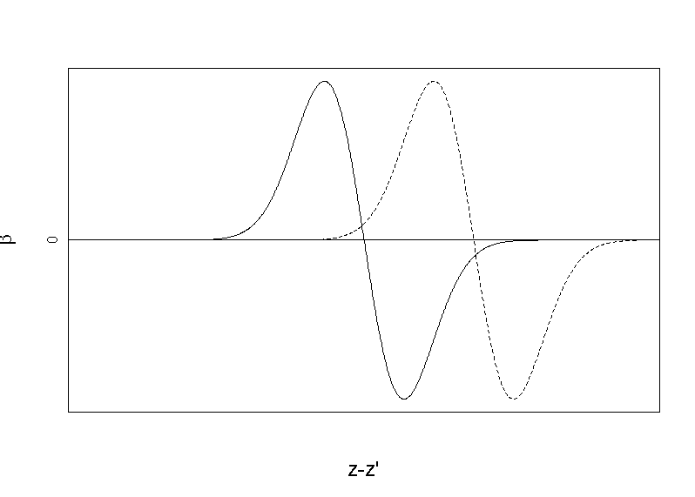

µB

µA

In this example, species A and B will very weakly affect each other’s trait evolution since they located far from peak values of each other’s β functions. Also, species located on the right of species B will have even weaker impact on species A and vice-versa. Therefore, similarly to the previous case, ff there are multiple species located on the left side species A which can strongly affect species A’s trait evolution (position close to the peak of β) , species A’s mean trait will increase (towards left) and similarly if there are multiple species located on the right side of species B that strongly affect B’s evolution, species B’s mean trait will decrease (towards left). This leads to convergent evolution between A and B.

Here, we demonstrated that, distance between a pair of species in focus as well as positions of all the other species along the trait axis is important in determining whether that pair will have convergent trait evolution. We further create sets of simulations where we alter the trait distances between a pair of species in focus (𝚫). We also arrange positions of other species in two specific ways: i) where most of the neighboring species are located very close to the peaks of species A and B’s β functions and ii) where most of the neighboring species are farther from the peaks of A and B’s β functions.

Using this setup, we let an initial setup of 20 species follow the dynamic from our model for one time-step and assess whether A and B converge.

Case 1:

The distance between two species in focus A (mean trait=µ A) and B (mean trait=µB), 𝚫 (delta) was varied between 0.1 and 5. Optimum distance between mean traits that maximizes the trait evolution was *opt* = $\sqrt{{{2σ}_{i}}^{2}+{{2σ}_{j}}^{2}+ω^{2}}$ ~ 2.06.

Mean trait values of the rest of the species in the model (n=20) were drawn from two normal distributions, Ɲ(µ A-opt, 0.1) (10 species on the left side of species A on trait axis) and Ɲ(µ B+opt, 0.1)(10 species on the right side of species B on trait axis), respectively. This design is intended to exert maximum impact of diffuse competition.

For each combination of threshold value and 𝚫f, 1000 sets of trait distributions were created using the system above and trait changes for the next time steps were calculated. Fractions of instances in which convergence was observed were plotted as a function 𝚫.

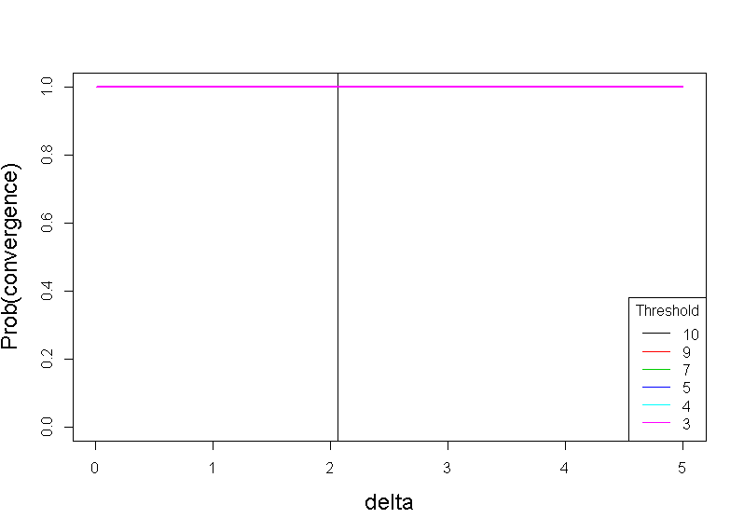

Case 2:

Mean trait values of the rest of the species in the model (n=20) were drawn from the distribution where probability of having a given trait value was inversely proportional to the β function value at that trait value. 10 values were drawn on the left side of µA and 10 values were drawn on the right side of µB along the trait axis. This distribution was intended to minimize the impact of diffuse competition on species A and B.

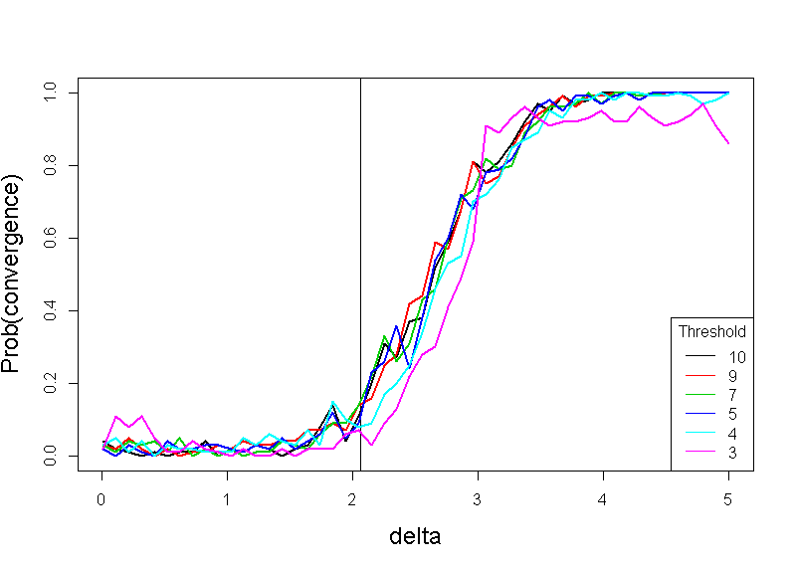

These two extreme scenarios show that the distance between mean traits of two competitors and dispersion of traits of diffuse competitors around the $\hat{Δ}$ (trait distance that has maximal impact on an evolution of a competitor) play a major role in likelihood of trait convergences. These results, however, do not show exactly how the trait evolution with time in other species can alter the strength of diffuse competition and thereby alter the likelihood of convergences.

Considering that the traits of all the competing species will generally diverge away with time, we can expect the diffuse competition to generally get weaker thus reducing the likelihood of convergence between a pair of species. However, introduction of threshold can limit the number of competitors and break the community into smaller groups where the diffuse competition, if present, will be strong, thus increasing the likelihood of convergence.

We show two cases of evolutionary dynamic for 2000 generations (with and without threshold to competition):

1. t=10 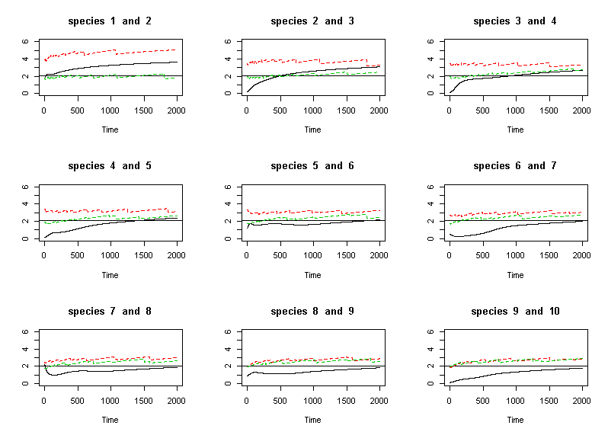
2. t=3 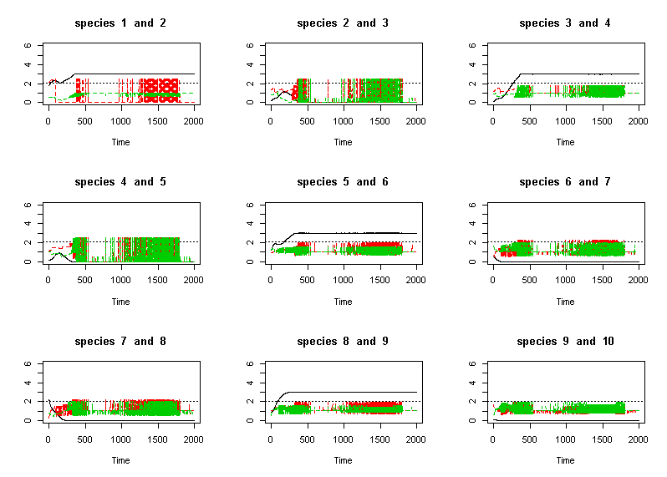

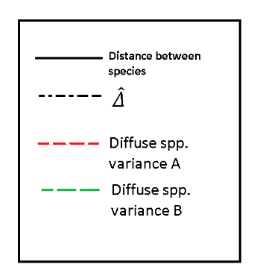

These two figures show the results of two simulations of 2000 generations of trait evolution, each started with a set of 20 species with arbitrarily assigned mean trait values with identical demographic parameters, trait variances and heritabilities. Omega=0.5. Each subplot in these figures shows how the distance between two neighboring species changes with time (solid black line). The dashed black line shows the value of $\hat{Δ}$ ~2.06. Green and red dashed lines show the variances of trait values of other competitors around the $\hat{Δ}$ of both species in focus. Higher variance indicates weaker diffuse competition. (*I just showed the first 9 pairs of species*) i) Threshold=10 ii) Threshold=3